**Steps before captured video**

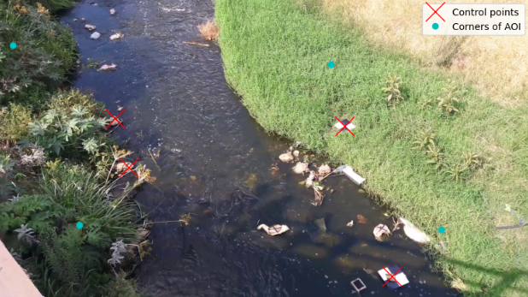

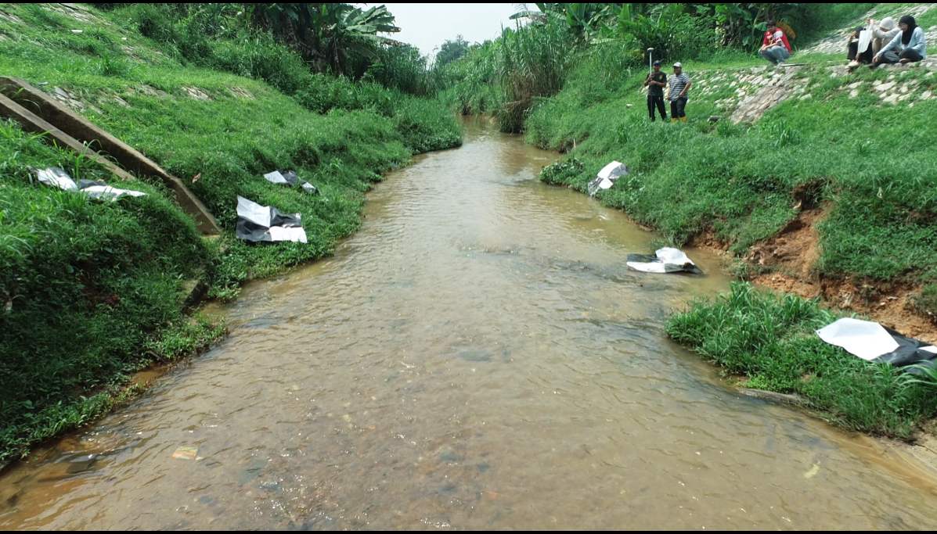

Kangkar pulai

Jalan Rotan Kangkar pulai

1. Site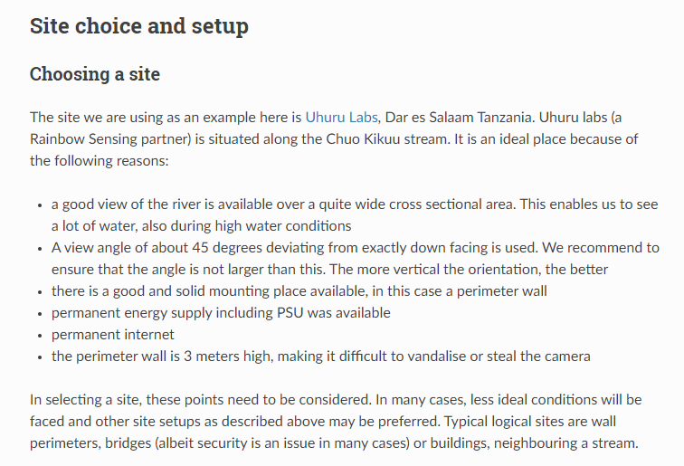
2. Materials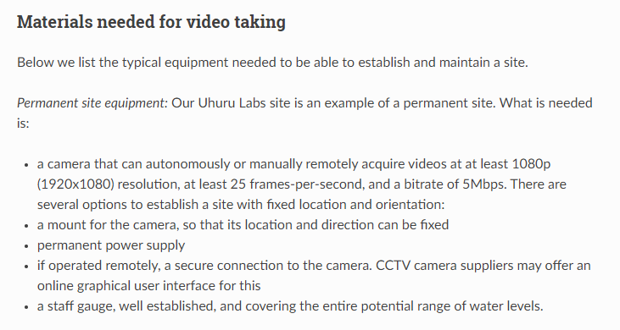

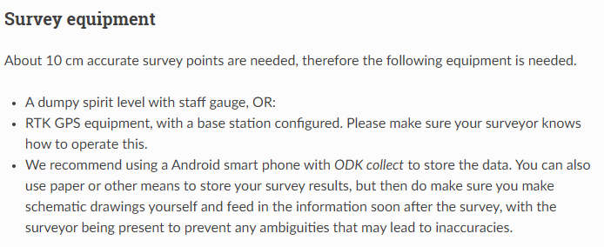

1. Video captured

* Gcp （image & UTM coordinates）
* Aoi
* Video
* cross section
* water level
* 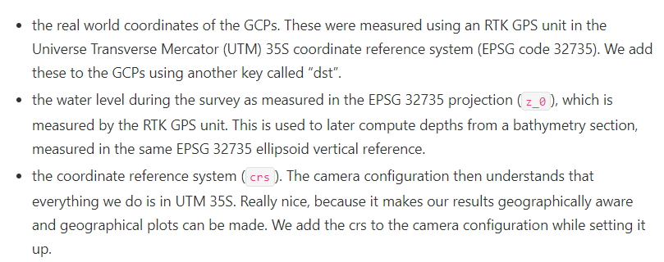
* 48 north

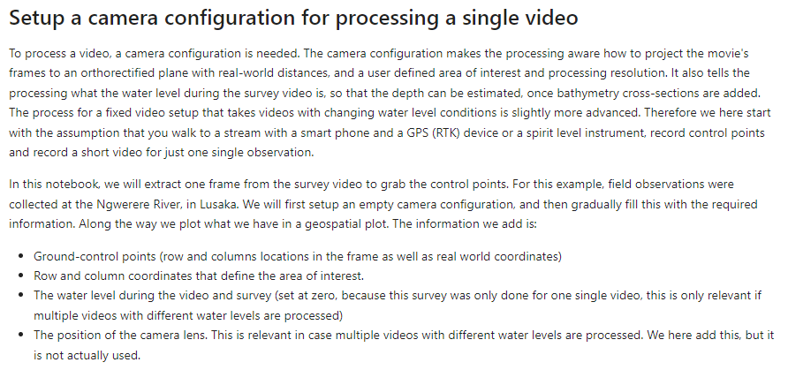

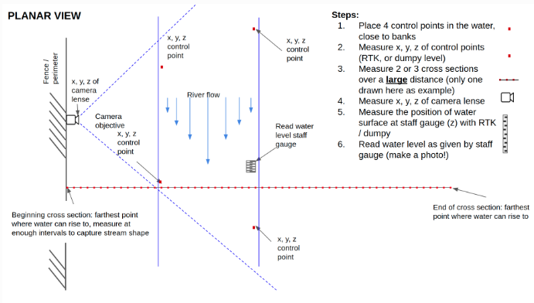

1. Cross section

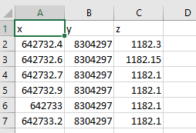

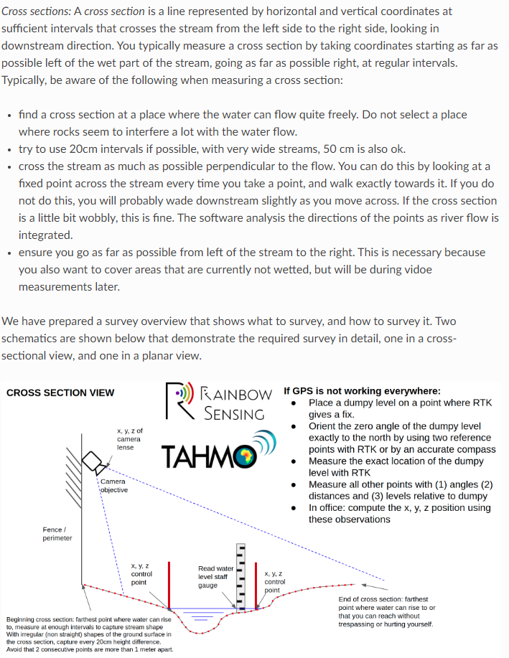

1. Gcp (crs & scr)

first add our UTM 35S coordinates. This MUST be in precisely the same order as the src coordinates.

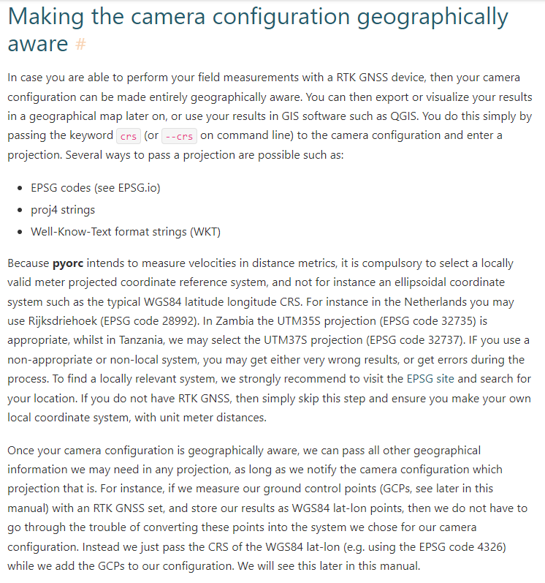

1. Water level

the water level during the survey as measured in the EPSG 32735 projection (z_0), which is measured by the RTK GPS unit.

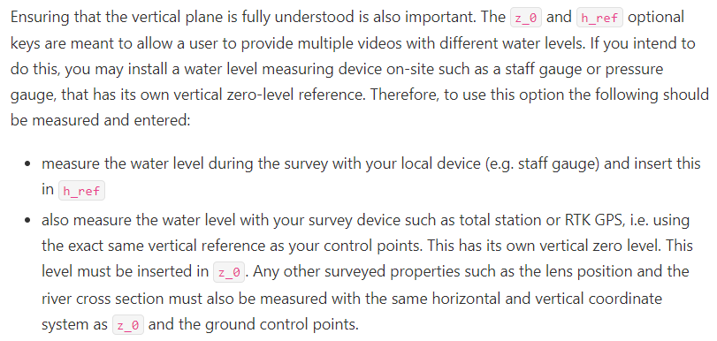

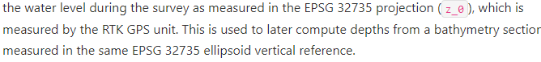

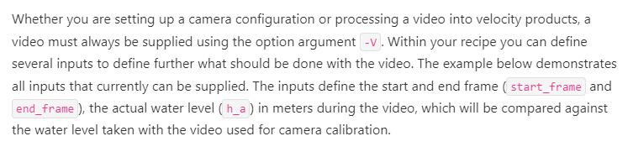

After setting up a site including a staff gauge, configuring the camera, and providing cross sections, individual short movies can be processed into surface flow velocities, and river discharge. Movies of 5 seconds at 1080p resolution and 25 or 30 frames per second at 5Mbps bit rate are enough to yield good results.